Vacuum Thermocouple Gauge

Nicolas Krause

**Introduction:**

This document describes the implementation of the Vacuum Thermocouple Gauge for my Fusor. It is made up of 4 separate components, the circuit, software, vacuum gauge and PCB.

**Circuit:**

A non-inverting amplifier built around a TLV2461 op-amp amplifies the signal from the vacuum gauge so that a microcontroller can measure it using an ADC. The implementation is inspired by [the Bell Jar’s](http://www.belljar.net/tcgauge.htm) original article.

My circuit implementation uses a non-inverting amplifier circuit and the TLV2461 device below.

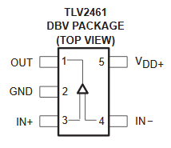

$$V_{o}=V_{i}\left(1+\frac{R_{f}}{R_{i}}\right)=V_{i}\left(1+\frac{3.3k}{47}\right)={71.2V}_{i}$$

The full schematic is viewable in the KiCad files. Given the values for R1 = 3.307K and R2 = 42.3 Ohms respectively, the actual precise amplification for my current built board is 78.2 times the input voltage.

**Software:**

The microcontroller program is written in mecrisp stellaris, a dialect of Forth. It polls the amplification circuit regularly and converts the measurement into a pressure value which it then prints out to a text LCD Screen. A Tiva C Series Launchpad development board is used to handle all of the necessary tasks. The following sequence allowed me to program my Tiva C series board for the TM4C123 chip.

1. Download Mecrisp-Stellaris
2. Download TI's Uniflash
3. Connect the Tiva C series board via usb and the debug port
4. Load mecrisp-stellaris-lm4f120.bin using Uniflash on to the board
5. Make a connection at 115200 baud rate via TeraTerm to the launchpad board.
6. Reset the board and the welcome message for mecrisp stellaris should appear.

Setting up mecrisp-stellaris took a bit of doing. The correct file has to be downloaded to the board and then a serial connection (via TeraTerm) needs to be established. To ensure legible output on the serial terminal, the following settings must be used on TeraTerm:

* 115200 baud rate
* Receive: AUTO
* Transmit: CR
* Data: 8 bit

The program has a number of words (Forth’s name for functions) that implement the program. They are described below:

AVERAGE: Produces an average of 8 input values.

ADCINIT: Initializes the ADC.

ADCREAD: Reads the ADC

SPIINIT: Initializes the SPI to communicate with the LCD

SEND: Sends a value over SPI to the LCD. Values are generally written in hex as that’s how the guide for the LCD denotes them.

CONVERT: Converts a voltage measurement to a pressure value. A vacuum thermocouple gauge has a calibration curve that relates the voltage it produces to a given pressure. Given the assumed KJL 1518/ 6343 type gauge the following set of data points is used to derive an exponential model for the CONVERT word. If you have a different type of tube you have to change this obviously. This can be viewed and edited in the calibration curve excel file included in this documentation.

The first chart above displays the curve relative to the actual voltage at the ADC while the second chart displays the curve relative to the value the ADC itself would put out. Given that it can produce 4096 values and its max reference voltage is 3.3V (see pg. 810 of the uC datasheet) we have the scale below.

UPDATE: This word prints out a pressure measurement to the LCD screen

RUN: Does exactly what it says, makes the whole program do its thing.

**PCB:**

The PCB is designed in KiCad and is made up of two components, the connector to the vacuum gauge and a board mounting the amplification circuit and microcontroller.

**Vacuum Gauge:**

The current gauge installed on the fusor is a Huntington Model 1504 (sometimes also GTC-004). It has 8 pins present on the gauge tube in an octal configuration (a legacy of vacuum tubes!) but only 4 are needed for the operation of the tube itself. A diagram of the pinout is below.

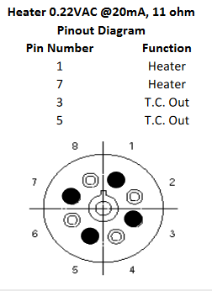

I guess for each of these pin connections I can hook up power and ground or sense and ground in any direction? We’ll stick to that for now.

**Board Improvements:**

The second revision includes a potentiometer for the power supply and a base 160 Ohm resistor to prevent filament burnout.